KL25 Signal Multiplexing and Pin Assignments

[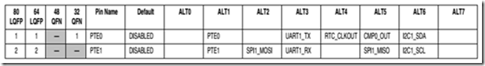](file:///C:\Users\LZJ\AppData\Local\Temp\WindowsLiveWriter1286139640\supfiles5581CFF\image3.png)

[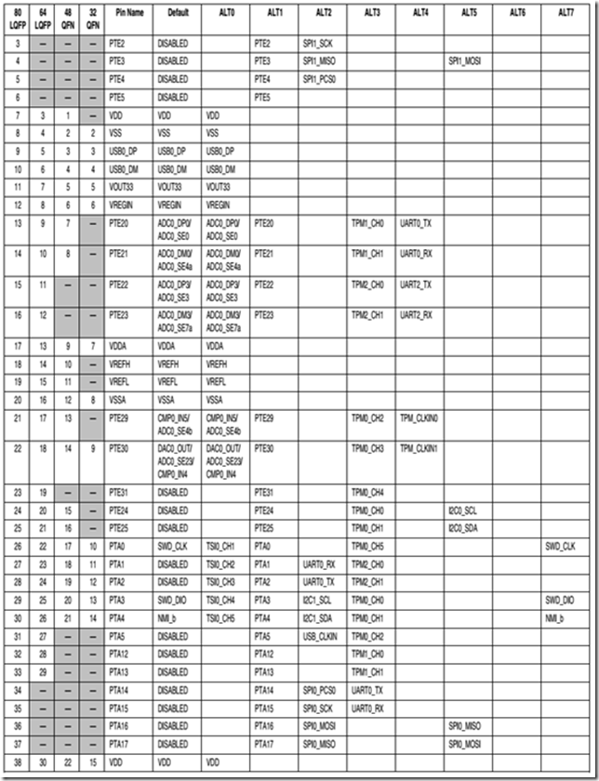](file:///C:\Users\LZJ\AppData\Local\Temp\WindowsLiveWriter1286139640\supfiles5581CFF\image17.png)

[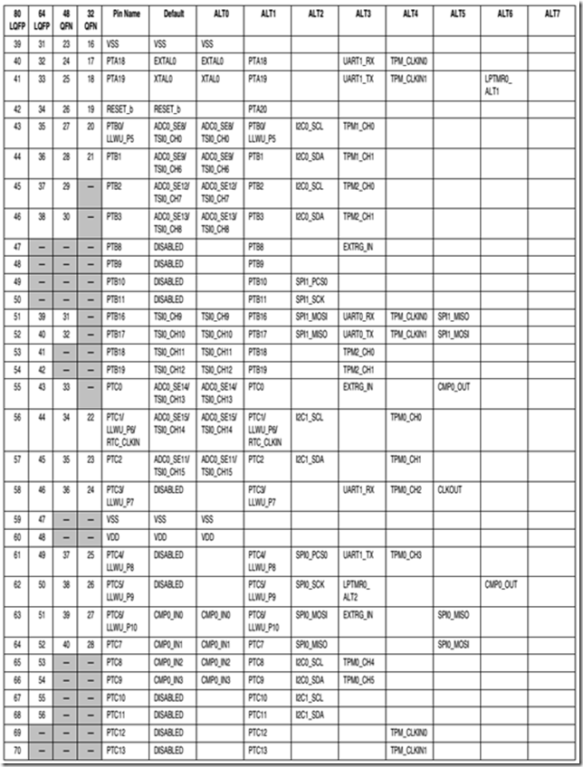](file:///C:\Users\LZJ\AppData\Local\Temp\WindowsLiveWriter1286139640\supfiles5581CFF\image18.png)

[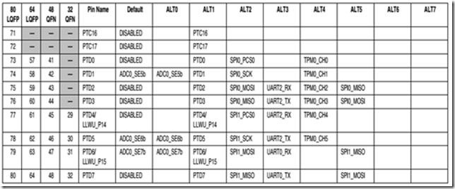](file:///C:\Users\LZJ\AppData\Local\Temp\WindowsLiveWriter1286139640\supfiles5581CFF\image19.png)